Lab_Day-6 (While Loop)

1. Write a python program to reverse a number using a while loop.

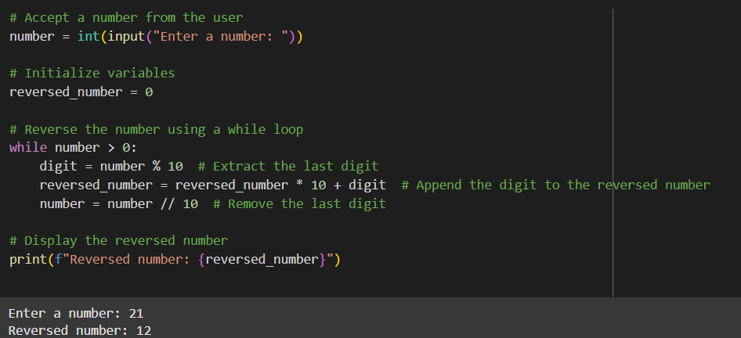

1. Write a python program to check whether a number is palindrome or not?

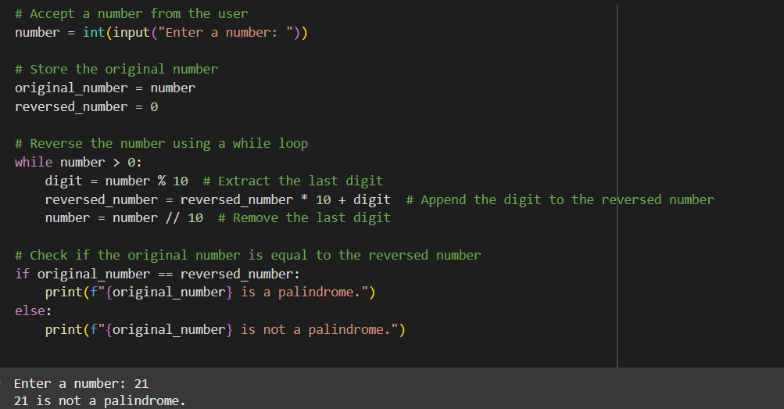

1. Write a python program finding the factorial of a given number using a while loop.

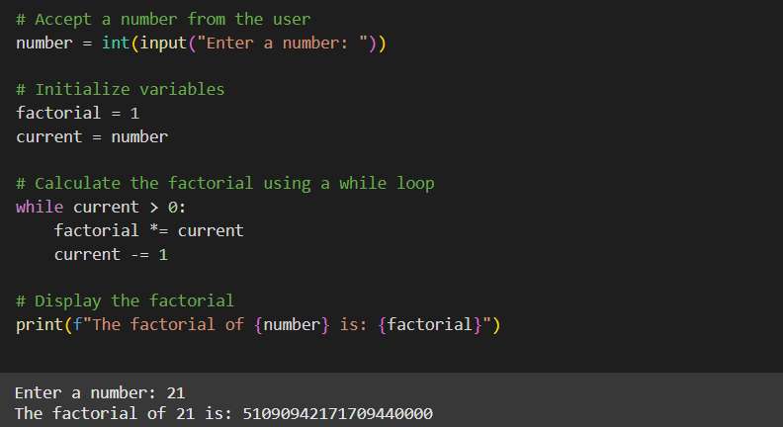

1. Accept numbers using input() function until the user enters 0. If user input 0 then break the while loop and display the sum of all the numbers.

